Exercise 3 a) proto io with navigation

Mageshwaran M
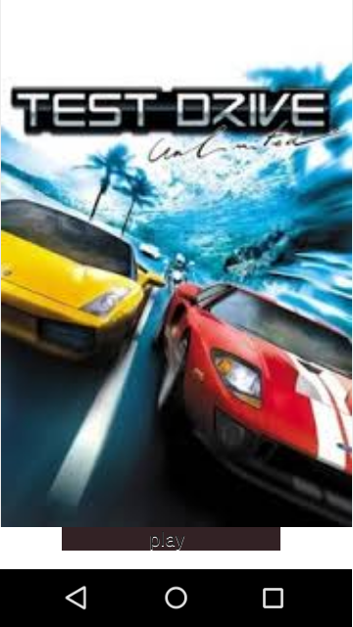
240701299

GAME CONCEPT OVERVIEW: TEST DRIVE UNLIMITED (FUTURISTIC FUTURE)
This document outlines the user interface and core gameplay elements of the proposed "Test Drive Unlimited" mobile game experience, as depicted in the provided high-fidelity prototype screens.
1. GAME TITLE AND AESTHETIC
Based on the image assets, the game is titled "TEST DRIVE Unlimited". While this title is historically associated with open-world coastal environments, the in-game screens and menu showcase a distinct, high-tech, and futuristic cyberpunk megacity at night. This new iteration blends the classic brand with a neon-lit, advanced urban setting.

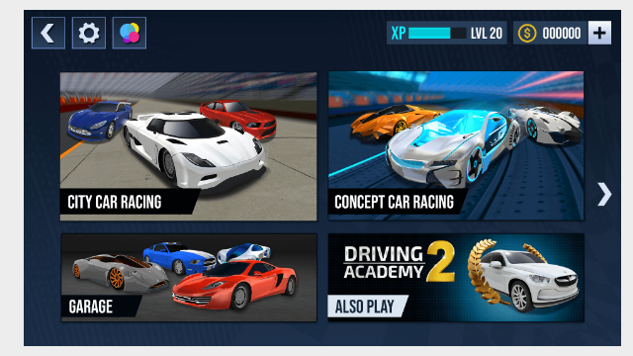

2. MAIN MENU (IMAGE 2)
The main menu serves as the hub, featuring several game mode selection tiles with visually distinct car types for each mode.
- Currency and Progression: The top-right shows the player's level ("LVL 20"), a blue Experience (XP) bar, and a current balance of in-game currency ("000000").
- Game Mode Tiles:
  - CITY CAR RACING: Features a blue sports car and a white sedan racing on a standard tarmac.
  - CONCEPT CAR RACING: Features highly futuristic, sleek concept cars with intricate lighting and advanced designs.
  - GARAGE: Shows an assortment of high-performance sports cars (grey, blue, red), indicating car collection and customization.
  - DRIVING ACADEMY 2: Displayed as an "ALSO PLAY" section with a gold laurel wreath and a white SUV, suggesting a tutorial or secondary challenge mode.
- Navigation: Top-left includes a standard Back arrow, a Settings gear, and a color palette (likely gallery or profile). A right-arrow implies more tiles are available.

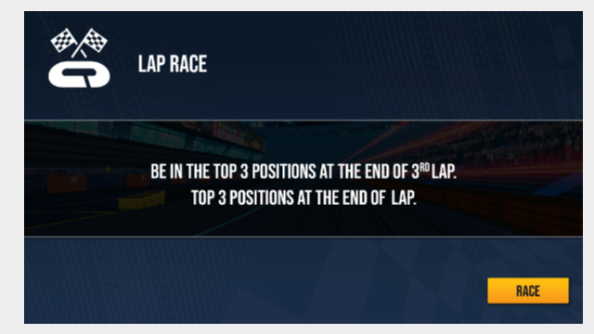

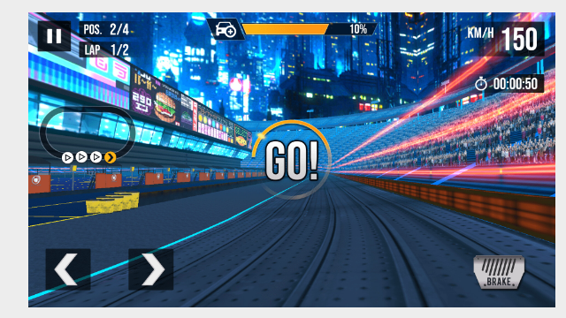

3. RACE OBJECTIVE SCREEN (IMAGE 1)
Before starting a race, players are presented with their objectives.
- Race Type: "LAP RACE" with a clear checkered flags logo.
- Primary Objective: "BE IN THE TOP 3 POSITIONS AT THE END OF 3RD LAP."
- Redundant Note: A repeating phrase "TOP 3 POSITIONS AT THE END OF LAP."
- Visual Background: A blurred pre-visual of the upcoming track at night, including some crowd seating.
- Action: A yellow "RACE" button initiates the event.
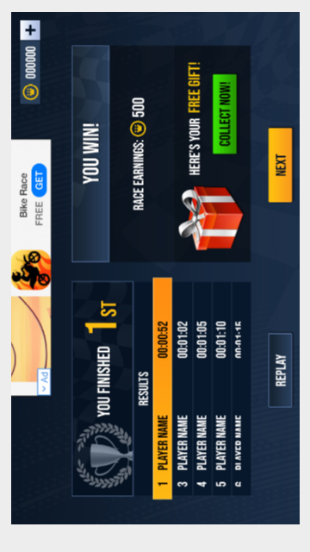

4. IN-GAME GAMEPLAY HUD (IMAGE 0)
The gameplay takes place from a first-person perspective or direct behind-the-car perspective, focusing down a neon-striped track towards a massive cyberpunk stadium filled with spectators. The detailed HUD (Heads-Up Display) is crucial for race management.
- Top Overlay:
  - Position and Lap: "POS. 2/4" (Player is 2nd of 4), "LAP 1/2" (Lap 1 of 2).
  - Progress Bar: A car icon on an orange-to-yellow bar, indicating completion percentage (e.g., "10%").
  - Pause Button.
- Right Overlay:
  - Speed: "KM/H 150".
  - Time: A stopwatch icon with the current timer (e.g., "00:00:50").
- In-Field UI:
  - "GO!" text appears large in the center with a circular countdown ring, just before the race starts or at a checkpoint.
- Bottom Overlay (Controls):
  - Left and Right steering arrow buttons.
  - A textured "BRAKE" pedal.
- Left Overlay (Mini-Map): A detailed oval-like circuit map is shown, with a sequence of checkmark icons (✓✓✓→) indicating progress checkpoints along the route.
- Environment Details: The track is lined with neon-lit futuristic skyscrapers, multi-level structures, and signs with stylized logos (like a burger sign). Crowd lighting is blue and vibrant.
5. SUMMARY OF EXPERIENCE
The game creates a high-stakes, fast-paced environment where the player, in control of a performance car, navigates complex urban tracks. Progression requires achieving specific placement goals across multiple laps. The combination of established branding and a new, futuristic aesthetic provides a fresh experience. The UI is designed for clear data delivery while maintaining immersive action.

